2022 Bat Guidance
Perhaps the most confusing and perplexing rules in youth baseball are directly related to bat standards. In youth baseball today there are two major bat standards…the USA bat standard and the USSSA bat standard. Here is a quick tutorial on each of the bat standards.
USA Bat Standard
- USABat is USA Baseball’s certification standard for youth baseball bats that establishes a wood-like performance for non-wood bats.
- Under the USABat standard, metal, and composite bats must feature the USABat certification mark to be authorized for play in youth leagues within the participating National Member Organizations. Solid, one piece wood bats may be used with or without the USA Baseball mark.
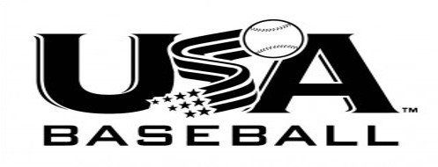
USSSA Bat Standard
To be eligible for play under USSSA bat standards a bat must:
- Have the new permanent(2) USSSA Mark on its taper OR
- Be a Qualified BBCOR bat(1) OR
- Be a Wood Bat
- ALL of the above must be manufactured by an approved USSSA Bat Licensee
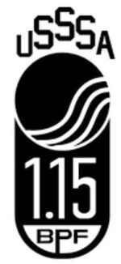
So What Does All of This Mean for Me?
In general, a USSSA bat will hit the ball harder than a USA bat of the same size. USA bats are manufactured to mimic a wood like performance. In general, due to their lower level of performance, USA bats are accepted in all levels of competition. USSSA bats, however, may not be accepted in all tournaments. So if you are looking to buy just one bat your best bet is purchase a USA bat as it is likely to be legal wherever a team plays.
Holmen Youth Baseball participates in the Seven Rivers Athletic Association (SRAA) for all LEAGUE play. The SRAA allows both USA and USSSA stamped bats in competition. Most tournaments hosted by communities who also participate in the SRAA will adhere to these same bat standards. Many tournaments outside of our local area, however, will adhere to the USA Standard only. Players should consult with their coaches to clarify the bat rules for the specific tournaments their team will be competing in during the season.
What are Bat Differentials?
Bat differentials also play a key role in determining which bats are eligible for use. Bat differential is simply the difference between the bat length and the bat weight. For example, a 31-inch bat that weighs 21 ounces has a bat differential of -10 (or drop 10). As players get older, the allowed bat differential decreases…in other words, the bats get heavier.
Listed below are the allowable bat differentials for the SRAA in league play for 2022. Be advised that some individual tournaments may have rules with different bat differentials. For example…Gold Level 13U tournaments will generally require a bat differential of -8 or less. And Gold Level 14U tournaments will generally require a bat differential of -5 or less. Players should consult with their coaches to clarify the bat rules for the specific tournaments their teams will be competing in during the season.
2021 SRAA Baseball Bat Information
2022 BASEBALL BAT INFORMATION
· Officially stamped USSSA & USA Bats are allowed (see images)
· 8U – Max diameter 2 ¾ inches, unlimited length & unlimited weight differential
· 9U-11U – Max diameter 2 ¾ inches, unlimited length & unlimited weight differential
· 12U – Max diameter 2 ¾ inches, max length 36 inches & max weight differential (-10)
· 13U – Max diameter 2 ¾ inches, max length 36 inches & max weight differential (-8)
· 14U – Max diameter 2 ¾ inches, max length 36 inches & max weight differential (-5)
· Other approved bats include: BBCOR & wood

